- INTRODUCTION:
Today all the work at the time of admission of the students is done manually by ink and paper, which is very slow and consuming much efforts and time. In the modern world of technology, computer are affecting our lives in more ways than we probably are aware of Computerized Management maintaining information of an educational institute, colleges, other the list is endless. The main principle behind the need of college admission system is easy supervision of institutes. It can handle the details of students such as personal details or admission details. This Student Database has been designed taking into account the practical needs to manage a Students data. Moreover, it provides security at product level as well as user level
2.ANALYSIS AND DESIGN:
Problem Specification
Student admissions are a vital part of any College’s running because students are what keep a College alive. The student admission is one of the most important activities within a College as one cannot survive without students. A poor admissions system can mean fewer students being admitted into a College because of mistakes or an overly slow response time. The process begins with a potential student completing an application form through the Universities and Colleges Admissions Service, the first step for students is to apply directly to the College through a custom online form. The next step is for the Admissions service center has to review the application and ensure that all of the required information has been provided. The application in its entirety is then forwarded, complete with a recommendation, to the respective department’s Admissions Tutor, who has the final say as to whether each potential student is Accepted or rejected. Before making a decision, the Admissions Tutor reviews the application and the additional documentation, comparing the academic credentials to a list of College rankings and previous, similar applications.
Background and Related Work
The main aim of our project is to develop the application which will be useful in college admission system. As this college admission system project includes the admission process of student, starting from when the student takes admission in college in first year till that submission of examination form from the college. The requirement of the student is to:
- User can contact with administrative by sending mails.
- User can view about us and contact us page.
- User can view notices which is published by admin.
- User can view courses which are listed by admin.
- User can register himself.
- After registration user can login into system and apply for admission.
- After successful submission of admission form application will pop up in admin panel for review.
- If application is selected user can submit their fees.
- User can update their profile details
- Change his / her own password.
- Admin login should be present who can read as well as view any uploads.
- Admin can select and reject any application.
- Admin can manage (add/update) the course.
- Admin can manage public notice.
- Admin can mange users (Students) enquiry.
- Admin can search application by application number.
- Admin can manage enquiry which is received by students.
- Admin can view subscriber mail.
- Admin can generate reports of application.
The student details in separate records are tedious task. Referring to all these records and updating is needed. Since the number of students are growing and management has to handle records of all of the students, it is facing the little bit problems in Maintaining the records of students
GOALS
The main goal of the system is to automate the process carried out in the organization with improved performance and realize the vision of paperless admission. Some of the goals of the system are listed below:
- Manage large number of student details.
- Manage all details of student who registered for the course and send appropriate details about the course to the students account.
- Create student accounts and maintain the data’s effectively.
- View all the details of the students.
- Create the statistical reports.

Reduce the work load in interview the students for selection and Counseling should be very effective rather than direct methods.

3. SYSTEM REQUIREMENT SPECIFICATION:
3.1 MODULE DESCRIPTION
Its design concentrates on 2 types of users:
- Admin
- Students
- Admin
- Dashboard: In this section, the admin can see all the detail in brief.
- Reg Users: In this section, the admin can view user detail, delete and update user detail.
- Admission Application: In this section, admin can view all applications. Admin can view applications and documents on the basis of status(pending application, approved an application, and reject application). Admin also can approve the pending application. (Whenever the admin changes the status of the application user will get an email notification). Note: The email function will not work in localhost.
- Search Application: In this section, admin can search applications on the basis of user name, email id, and contact number.
- Course: In this section, admin can manage courses(add, delete and update).
- Notice: In this section, admin can manage notice(add and update) and anybody see this notice on the website.
- Notification: In this section, admin gets the notification if any user applies for admission.
- Pages: In this section, Admin can manage the content of the about us and contact us page.
- Subscribers: In this action , admin can view the subscriber list.
- Reports: In this section, admin can generate the report b/w dates.
- Students
- User can contact the administrator by sending mails.
- User can view the about us and contact us page.
- User can view notices which are published by the admin.
- User can view courses that are listed by the admin.
- User can register themselves.
- After User/Student Login
- Dashboard: In this section, user can see the status of his application.
- Admission Form: In this section, user can fill the form and check his / her application form is selected or rejected (which is done by admin).
- Submit Fees: In this section, if user/student application is selected user can submit their fees.
A user can also update his/ her profile, change the password and recover the password.

3.2 SDLC METHODOLOGIES

Waterfall Model is efficient for this project because of life cycle each phase is completed in sequence and then the results of the phase flow on to the next phase. There is no going back once the phase is completed. This process defines definite starting and ending points of a project. It is short-term project, so the waterfall is suitable for this project.

Following is a diagrammatic representation of different phases of waterfall model.
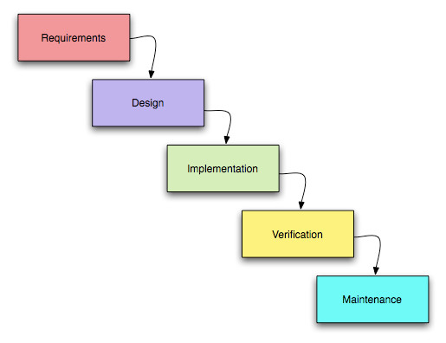
The sequential phases in Waterfall model are:
- Requirement Gathering and analysis: All possible requirements of the system to be developed are captured in this phase and documented in a requirement specification doc.
- System Design: The requirement specifications from first phase are studied in this phase and system design is prepared. System Design helps in specifying hardware and system requirements and also helps in defining overall system architecture.
- Implementation: With inputs from system design, the system is first developed in small programs called units, which are integrated in the next phase. Each unit is developed and tested for its functionality which is referred to as Unit Testing.
- Integration and Testing: All the units developed in the implementation phase are integrated into a system after testing of each unit. Post integration the entire system is tested for any faults and failures.
- Deployment of system: Once the functional and non functional testing is done, the product is deployed in the customer environment or released into the market.
- Maintenance: There are some issues which come up in the client environment. To fix those issues patches are released. Also to enhance the product some better versions are released. Maintenance is done to deliver these changes in the customer environment.
All these phases are cascaded to each other in which progress is seen as flowing steadily downwards (like a waterfall) through the phases. The next phase is started only after the defined set of goals are achieved for previous phase and it is signed off, so the name "Waterfall Model". In this model phases do not overlap.
3.3 SOFTWARE REQUIREMENTS:
- Operating System :Windows XP or higher
- Server : XAMPP
- Front End : HTML, CSS.
- Scripting : JavaScript.
- Database : MySQL
- Database Connectivity : PhpMyAdmin.
- Programming Language : PHP.

3.4 HARDWARE REQUIREMENTS:
- Operating System : Windows 7 or higher
- Processor : Intel Core processor or above
- RAM : 4 GB or above
- Hard Disk : 40 GB or above
4. SYSTEM DESIGN:
4.1.Use Case Diagram:
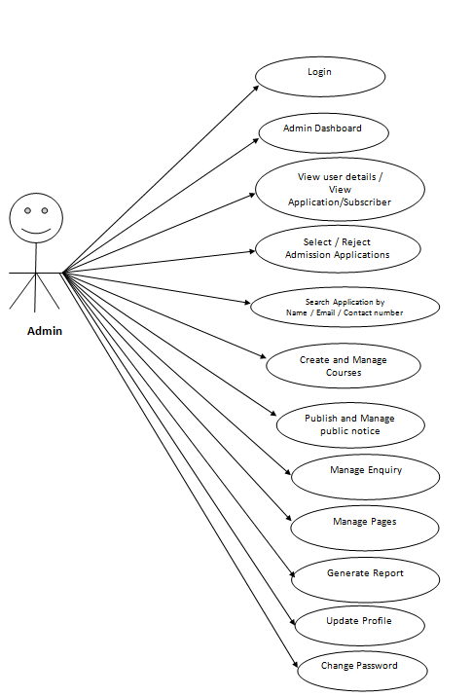

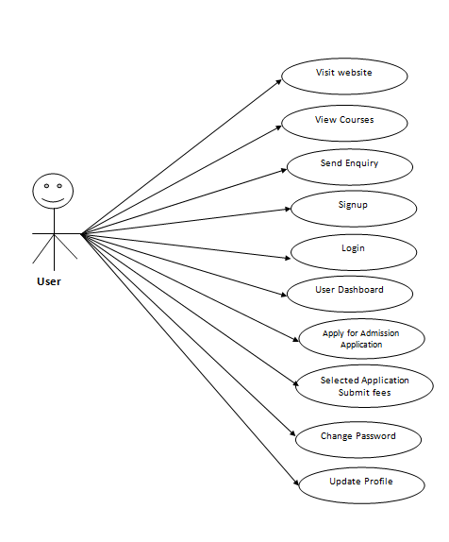

4.2 Class Diagram:
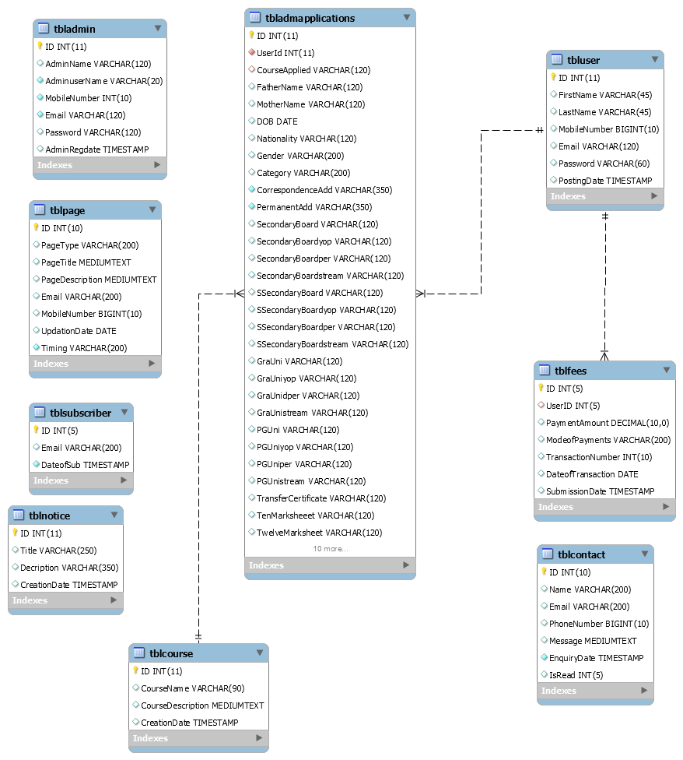

4.3 E-R Diagram:
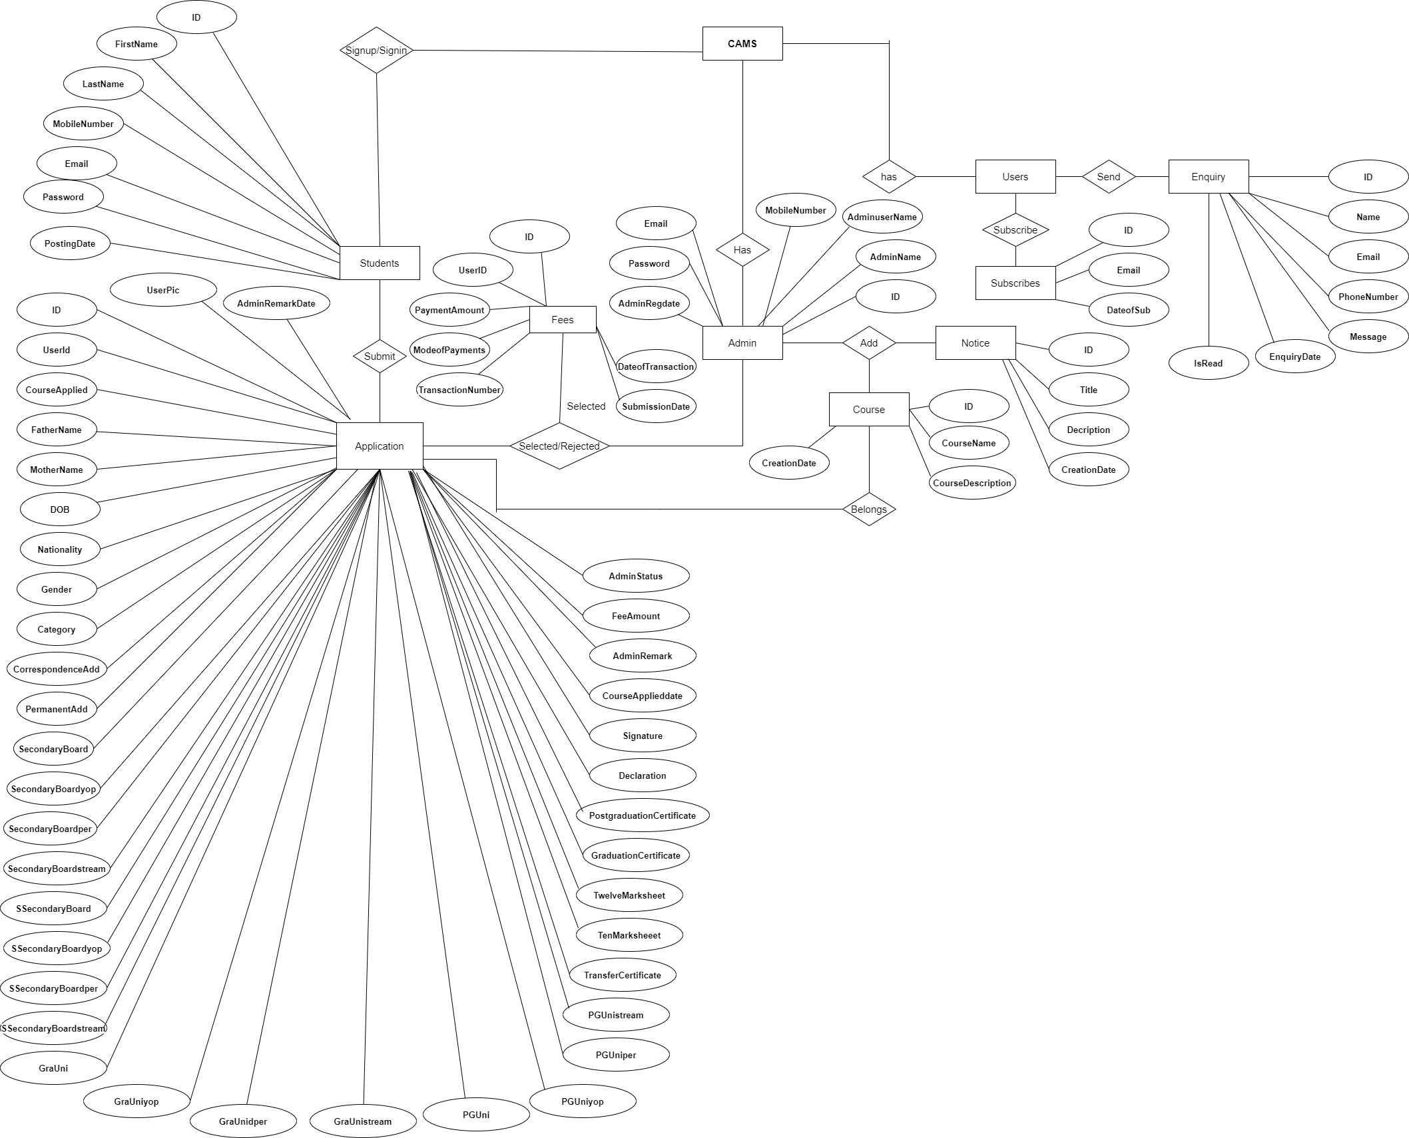

4.4 MySQL Data Tables:
tbladmin
This table stores the login details of admin.

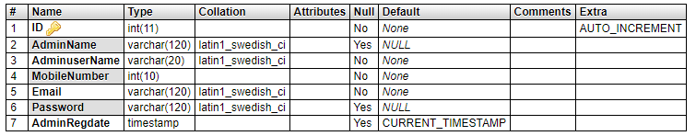

tbluser
This table stores the details of registered users.
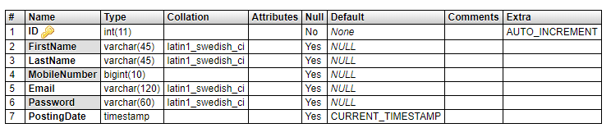
tblcourse
This table store the details of course which is provided by college.

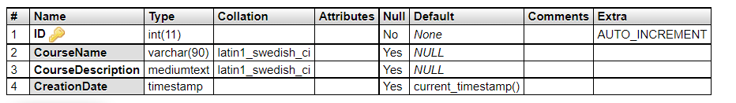

tbladmapplications

This table stores the application details which is received by students.
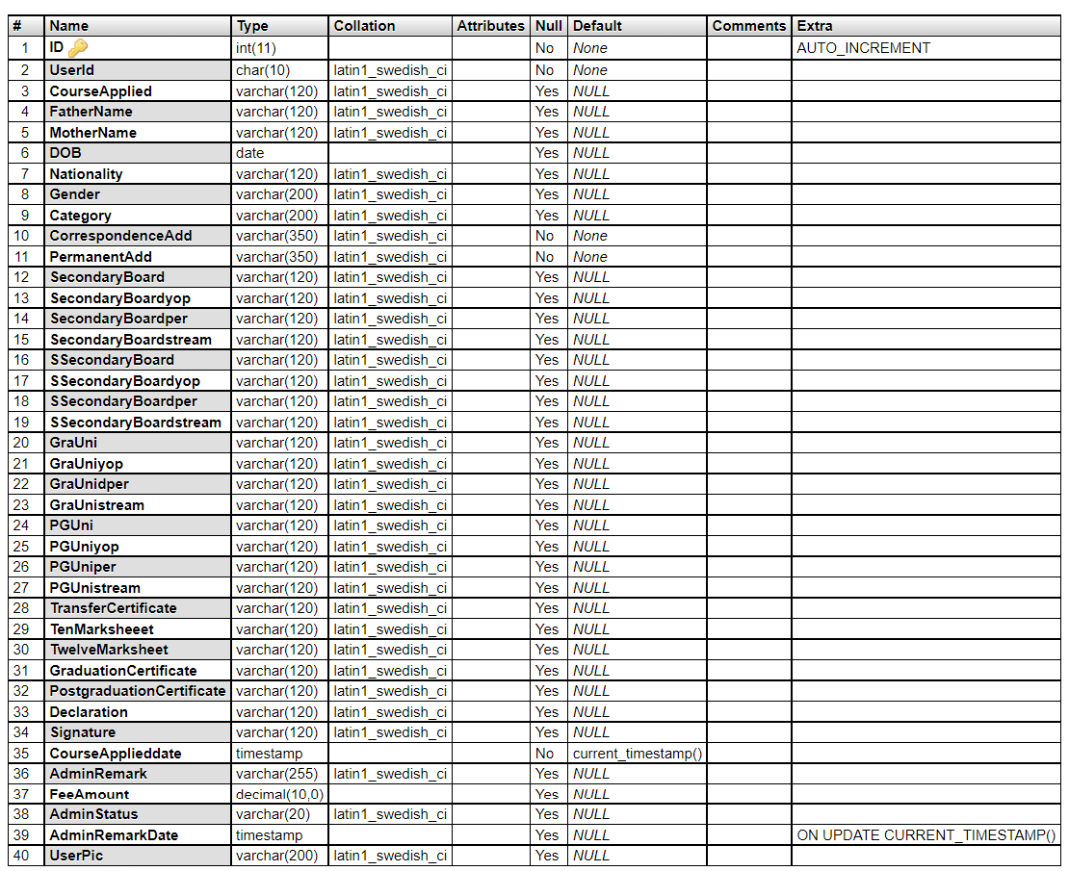

tblnotice
This table store the details of notice which is generated by admin

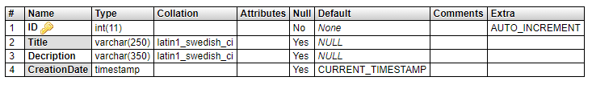

Tblcontact

This table stores the data of enquiry which is send by users.
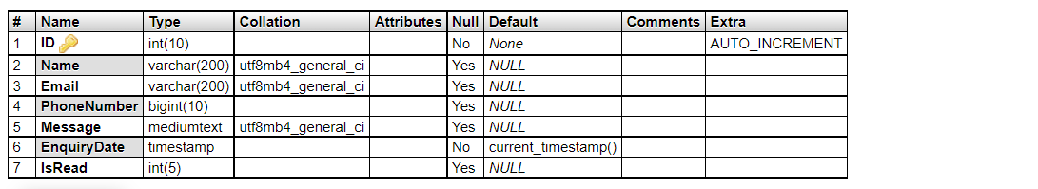

tblpage
This table store the data of about us and contact us.

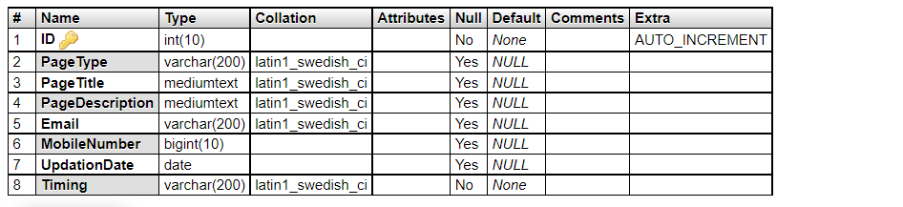

tblsubscriber
This table stores the emails id of subscribers.

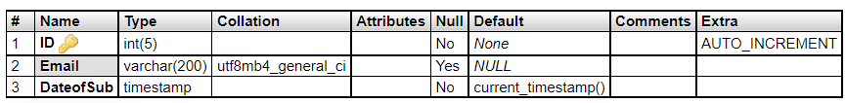

5. TECHNOLOGY DESCRIPTION
HTML
HTML, stands for of Hypertext Markup Language, is the predominant markup language for web pages. It provides a means to describe the structure of text-based information in a document - by denoting certain text as headings, paragraphs, lists, and so on - and to supplement that text with interactive forms, embedded images, and other objects. HTML is written in the form of labels (known as tags), surrounded by angle brackets. HTML can also describe, to some degree, the appearance and semantics of a document, and can include embedded scripting language code which can affect the behavior of web browsers and other HTML processors.
HTML is also often used to refer to content of the MIME type text/html or even more broadly as a generic term for HTML whether in its XML-descended form (such as XHTML 1.0 and later) or its form descended directly from SGML Hyper Text Markup Language
Hypertext Markup Language (HTML), the languages of the World Wide Web (WWW), allows users to produces Web pages that include text, graphics and pointer to other Web pages (Hyperlinks).

HTML is not a programming language but it is an application of ISO Standard 8879, SGML (Standard Generalized Markup Language), but specialized to hypertext and adapted to the Web. The idea behind Hypertext is that instead of reading text in rigid linear structure, we can easily jump from one point to another point. We can navigate through the information based on our interest and preference. A markup language is simply a series of elements, each delimited with special characters that define how text or other items enclosed within the elements should be displayed. Hyperlinks are underlined or emphasized works that load to other documents or some portions of the same document.

HTML can be used to display any type of document on the host computer, which can be geographically at a different location. It is a versatile language and can be used on any platform or desktop.

HTML provides tags (special codes) to make the document look attractive. HTML tags are not case-sensitive. Using graphics, fonts, different sizes, color, etc., can enhance the presentation of the document. Anything that is not a tag is part of the document itself.

Basic HTML Tags:
<! -- --> specifies comments
<A>……….</A> Creates hypertext links
<B>……….</B> Formats text as bold
<BIG>……….</BIG> Formats text in large font.
<BODY>…</BODY> Contains all tags and text in the HTML document
<CENTER>...</CENTER> Creates text
<DD>…</DD> Definition of a term
<DL>...</DL> Creates definition list
<FONT>…</FONT> Formats text with a particular font
<FORM>...</FORM> Encloses a fill-out form
<FRAME>...</FRAME> Defines a particular frame in a set of frames
<H#>…</H#> Creates headings of different levels(1 – 6 )
<HEAD>...</HEAD> Contains tags that specify information about a document
<HR>...</HR> Creates a horizontal rule
<HTML>…</HTML> Contains all other HTML tags
<META>...</META> Provides meta-information about a document
<SCRIPT>…</SCRIPT> Contains client-side or server-side script
<TABLE>…</TABLE> Creates a table
<TD>…</TD> Indicates table data in a table
<TR>…</TR> Designates a table row
<TH>…</TH> Creates a heading in a table

Attributes
The attributes of an element are name-value pairs, separated by "=", and written within the start label of an element, after the element's name. The value should be enclosed in single or double quotes, although values consisting of certain characters can be left unquoted in HTML (but not XHTML).Leaving attribute values unquoted is considered unsafe.
Most elements take any of several common attributes: id, class, style and title. Most also take language-related attributes: lang and dir.
The id attribute provides a document-wide unique identifier for an element. This can be used by stylesheets to provide presentational properties, by browsers to focus attention on the specific element or by scripts to alter the contents or presentation of an element. The class attribute provides a way of classifying similar elements for presentation purposes. For example, an HTML document (or a set of documents) may use the designation class="notation" to indicate that all elements with this class value are all subordinate to the main text of the document (or documents). Such notation classes of elements might be gathered together and presented as footnotes on a page, rather than appearing in the place where they appear in the source HTML.
An author may use the style non-attributal codes presentational properties to a particular element. It is considered better practice to use an element’s son- id page and select the element with a stylesheet, though sometimes this can be too cumbersome for a simple ad hoc application of styled properties. The title is used to attach subtextual explanation to an element. In most browsers this title attribute is displayed as what is often referred to as a tooltip. The generic inline span element can be used to demonstrate these various non-attributes.
The preceding displays as HTML (pointing the cursor at the abbreviation should display the title text in most browsers).
Advantages
- A HTML document is small and hence easy to send over the net. It is small because it does not include formatted information.
- HTML is platform independent.
- HTML tags are not case-sensitive.
JavaScript
JavaScript is a script-based programming language that was developed by Netscape Communication Corporation. JavaScript was originally called Live Script and renamed as JavaScript to indicate its relationship with Java. JavaScript supports the development of both client and server components of Web-based applications. On the client side, it can be used to write programs that are executed by a Web browser within the context of a Web page. On the server side, it can be used to write Web server programs that can process information submitted by a Web browser and then update the browser’s display accordingly.
Even though JavaScript supports both client and server Web programming, we prefer JavaScript at Client side programming since most of the browsers supports it. JavaScript is almost as easy to learn as HTML, and JavaScript statements can be included in HTML documents by enclosing the statements between a pair of scripting tags
<SCRIPTS>..</SCRIPT>.
<SCRIPT LANGUAGE = “JavaScript”>
JavaScript statements
</SCRIPT>
Here are a few things we can do with JavaScript:
- Validate the contents of a form and make calculations.
- Add scrolling or changing messages to the Browser’s status line.
- Animate images or rotate images that change when we move the mouse over them.
- Detect the browser in use and display different content for different browsers.
- Detect installed plug-ins and notify the user if a plug-in is required.
We can do much more with JavaScript, including creating entire application.

Advantages
- JavaScript can be used for Sever-side and Client-side scripting.
- It is more flexible than VBScript.
- JavaScript is the default scripting languages at Client-side since all the browsers supports it.
PHP Technology
The PHP Hypertext Preprocessor (PHP) is a programming language that allows web developers to create dynamic content that interacts with databases. PHP is basically used for developing web based software applications. PHP is an interpreted language, i.e. there is no need for compilation.PHP is a server side scripting language.PHP is faster than other scripting language e.g. asp and jsp.
PHP started out as a small open source project that evolved as more and more people found out how useful it was. RasmusLerdorf unleashed the first version of PHP way back in 1994.
- PHP is a recursive acronym for "PHP: Hypertext Preprocessor".
- PHP is a server side scripting language that is embedded in HTML. It is used to manage dynamic content, databases, session tracking, even build entire e-commerce sites.
- It is integrated with a number of popular databases, including MySQL, PostgreSQL, Oracle, Sybase, Informix, and Microsoft SQL Server.
- PHP is pleasingly zippy in its execution, especially when compiled as an Apache module on the Unix side. The MySQL server, once started, executes even very complex queries with huge result sets in record-setting time.
- PHP supports a large number of major protocols such as POP3, IMAP, and LDAP. PHP4 added support for Java and distributed object architectures (COM and CORBA), making n-tier development a possibility for the first time.
- PHP is forgiving: PHP language tries to be as forgiving as possible.
- PHP Syntax is C-Like.

Common uses of PHP:
- PHP performs system functions, i.e. from files on a system it can create, open, read, write, and close them.
- PHP can handle forms, i.e. gather data from files, save data to a file, through email you can send data, return data to the user.
- You add, delete, modify elements within your database through PHP.
- Access cookies variables and set cookies.
- Using PHP, you can restrict users to access some pages of your website.
- It can encrypt data.

Characteristics of PHP
Five important characteristics make PHP's practical nature possible −
- Simplicity
- Efficiency
- Security
- Flexibility
- Familiarity

"Hello World" Script in PHP
To get a feel for PHP, first start with simple PHP scripts. Since "Hello, World!" is an essential example, first we will create a friendly little "Hello, World!" script.
As mentioned earlier, PHP is embedded in HTML. That means that in amongst your normal HTML (or XHTML if you're cutting-edge) you'll have PHP statements like this −
<html>
<head>
<title>Hello World</title>
</head>
<body>
<?php echo "Hello, World!";?>
</body>
</html>
It will produce following result −
Hello, World!
If you examine the HTML output of the above example, you'll notice that the PHP code is not present in the file sent from the server to your Web browser. All of the PHP present in the Web page is processed and stripped from the page; the only thing returned to the client from the Web server is pure HTML output.
All PHP code must be included inside one of the three special markup tags ate are recognised by the PHP Parser.
<?php PHP code goes here ?>
<? PHP code goes here ?>
<scriptlanguage="php"> PHP code goes here </script>
A most common tag is the <?php...?> and we will also use the same tag in our tutorial.
From the next chapter we will start with PHP Environment Setup on your machine and then we will dig out almost all concepts related to PHP to make you comfortable with the PHP language.
Database:
A database management system (DBMS) is computer software designed for the purpose of managing databases, a large set of structured data, and run operations on the data requested by numerous users. Typical examples of DBMSs include Oracle, DB2, Microsoft Access, Microsoft SQL Server, Firebird, PostgreSQL, MySQL, SQLite, FileMaker and Sybase Adaptive Server Enterprise. DBMSs are typically used by Database administrators in the creation of Database systems. Typical examples of DBMS use include accounting, human resources and customer support systems.

Originally found only in large companies with the computer hardware needed to support large data sets, DBMSs have more recently emerged as a fairly standard part of any company back office.

Description
A DBMS is a complex set of software programs that controls the organization, storage, management, and retrieval of data in a database. A DBMS includes:
- A modeling language to define the schema of each database hosted in the DBMS, according to the DBMS data model.
- The four most common types of organizations are the hierarchical, network, relational and object models. Inverted lists and other methods are also used. A given database management system may provide one or more of the four models. The optimal structure depends on the natural organization of the application's data, and on the application's requirements (which include transaction rate (speed), reliability, maintainability, scalability, and cost).
- The dominant model in use today is the ad hoc one embedded in SQL, despite the objections of purists who believe this model is a corruption of the relational model, since it violates several of its fundamental principles for the sake of practicality and performance. Many DBMSs also support the Open Database Connectivity API that supports a standard way for programmers to access the DBMS.
- Data structures (fields, records, files and objects) optimized to deal with very large amounts of data stored on a permanent data storage device (which implies relatively slow access compared to volatile main memory).
- A database query language and report writer to allow users to interactively interrogate the database, analyze its data and update it according to the users privileges on data.
- It also controls the security of the database.
- Data security prevents unauthorized users from viewing or updating the database. Using passwords, users are allowed access to the entire database or subsets of it called subschemas. For example, an employee database can contain all the data about an individual employee, but one group of users may be authorized to view only payroll data, while others are allowed access to only work history and medical data.
- If the DBMS provides a way to interactively enter and update the database, as well as interrogate it, this capability allows for managing personal databases. However, it may not leave an audit trail of actions or provide the kinds of controls necessary in a multi-user organization. These controls are only available when a set of application programs are customized for each data entry and updating function.
- A transaction mechanism, that ideally would guarantee the ACID properties, in order to ensure data integrity, despite concurrent user accesses (concurrency control), and faults (fault tolerance).
- It also maintains the integrity of the data in the database.
- The DBMS can maintain the integrity of the database by not allowing more than one user to update the same record at the same time. The DBMS can help prevent duplicate records via unique index constraints; for example, no two customers with the same customer numbers (key fields) can be entered into the database. See ACID properties for more information (Redundancy avoidance).
The DBMS accepts requests for data from the application program and instructs the operating system to transfer the appropriate data.
When a DBMS is used, information systems can be changed much more easily as the organization's information requirements change. New categories of data can be added to the database without disruption to the existing system.
Organizations may use one kind of DBMS for daily transaction processing and then move the detail onto another computer that uses another DBMS better suited for random inquiries and analysis. Overall systems design decisions are performed by data administrators and systems analysts. Detailed database design is performed by database administrators.
Database servers are specially designed computers that hold the actual databases and run only the DBMS and related software. Database servers are usually multiprocessor computers, with RAID disk arrays used for stable storage. Connected to one or more servers via a high-speed channel, hardware database accelerators are also used in large volume transaction processing environments.
DBMSs are found at the heart of most database applications. Sometimes DBMSs are built around a private multitasking kernel with built-in networking support although nowadays these functions are left to the operating system.

SQL
Structured Query Language (SQL) is the language used to manipulate relational databases. SQL is tied very closely with the relational model.
In the relational model, data is stored in structures called relations or tables.
SQL statements are issued for the purpose of:
Data definition: Defining tables and structures in the database (DDL used to create, alter and drop schema objects such as tables and indexes).
Data manipulation: Used to manipulate the data within those schema objects (DML Inserting, Updating, Deleting the data, and Querying the Database).
A schema is a collection of database objects that can include: tables, views, indexes and sequences
List of SQL statements that can be issued against an Oracle database schema are:
- ALTER - Change an existing table, view or index definition (DDL)
- AUDIT - Track the changes made to a table (DDL)
- COMMENT - Add a comment to a table or column in a table (DDL)
- COMMIT - Make all recent changes permanent (DML - transactional)
- CREATE - Create new database objects such as tables or views (DDL)
- DELETE- Delete rows from a database table (DML)
- DROP - Drop a database object such as a table, view or index (DDL)
- GRANT - Allow another user to access database objects such as tables or views (DDL)
- INSERT - Insert new data into a database table (DML)
- No AUDIT - Turn off the auditing function (DDL)
- REVOKE - Disallow a user access to database objects such as tables and views (DDL)
- ROLLBACK - Undo any recent changes to the database (DML - Transactional)
- SELECT - Retrieve data from a database table (DML)
- TRUNCATE - Delete all rows from a database table (can not be rolled back) (DML)
- UPDATE- Change the values of some data items in a database table (DML)

MySQL
MySQL is the most popular Open Source Relational SQL database management system. It is one of the best RDBMS being used for developing web-based software applications.MySQL can be used for a variety of applications, but is most commonly found on Web servers. A website that uses MySQL may include Web pages that access information from a database. These pages are often referred to as "dynamic," meaning the content of each page is generated from a database as the page loads. Websites that use dynamic Web pages are often referred to as database-driven websites.
Dreamweaver
Adobe Dreamweaver is a proprietary web development tool developed by Adobe Systems. Dreamweaver was created by Macromedia in 1997,and was maintained by them until Macromedia was acquired by Adobe Systems in 2005. Adobe Dreamweaver is available for macOS and for Windows.Adobe Dreamweaver CC is a web design and development application that combines a visual design surface known as Live View and a code editor with standard features such as syntax highlighting, code completion, and code collapsing as well as more sophisticated features such as real-time syntax checking and code introspection for generating code hints to assist the user in writing code.
XAMPP
XAMPP stands for Cross-Platform (X), Apache (A), MySQL (M), PHP (P) and Perl (P). It is a simple, lightweight Apache distribution that makes it extremely easy for developers to create a local web server for testing purposes. Everything you need to set up a web server – server application (Apache), database (MySQL), and scripting language (PHP) – is included in a simple extractable file. XAMPP is also cross-platform, which means it works equally well on Linux, Mac and Windows.
I am using XamppServer for my project, you can download it from the following link:
http://www.apachefriends.org/en/xampp-windows.html
After downloading, just follow the following step to start xampp server:
Step1 - Install XAMPP
Step2- Assumeyou installed xampp in C Drive.
Go to: C:\xampp\htdocs. Create your own folder, name it for example as peer review.
Step3 - Now create your first php program in xampp and name it as “add.php”:
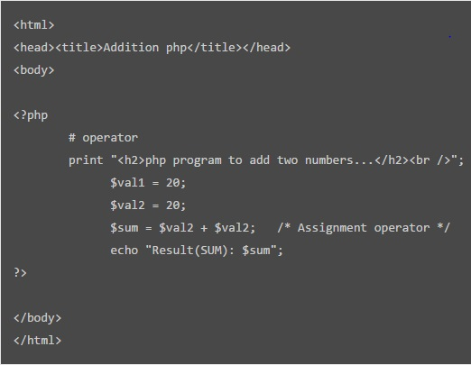
Figure: add.php
Step4 - Now double click on “XAAMP CONTROL PANEL” on desktop and START “Apache”
(icon also appears on the bottom)
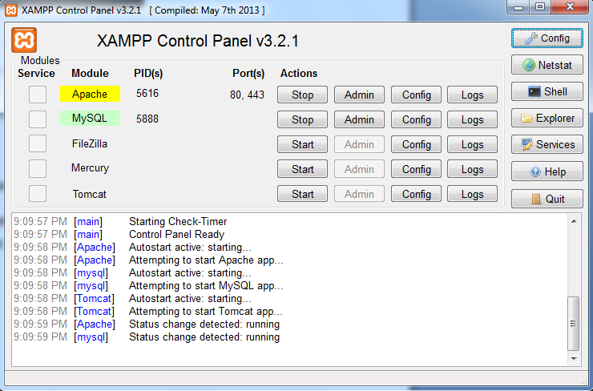
Figure: Xampp control panel
Step5 - Type localhost on your browser and press enter:
It will show the following:
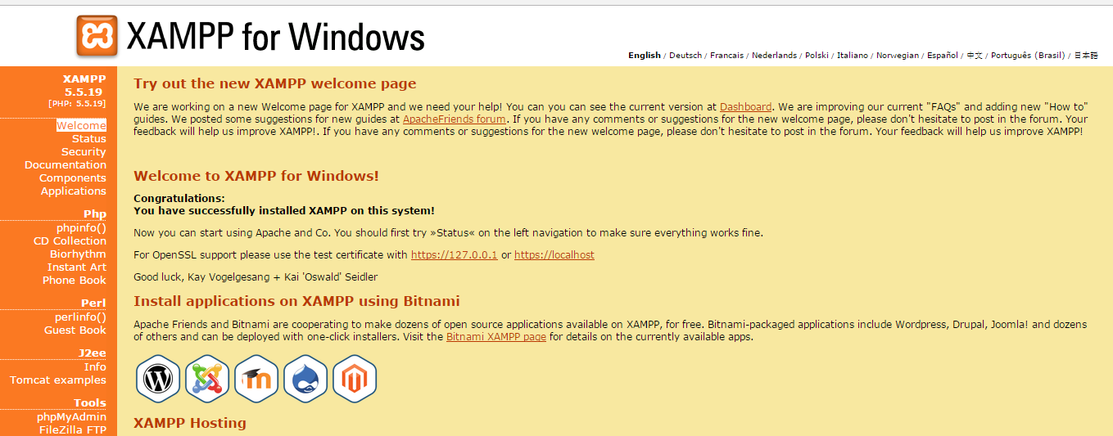
Figure: localhost
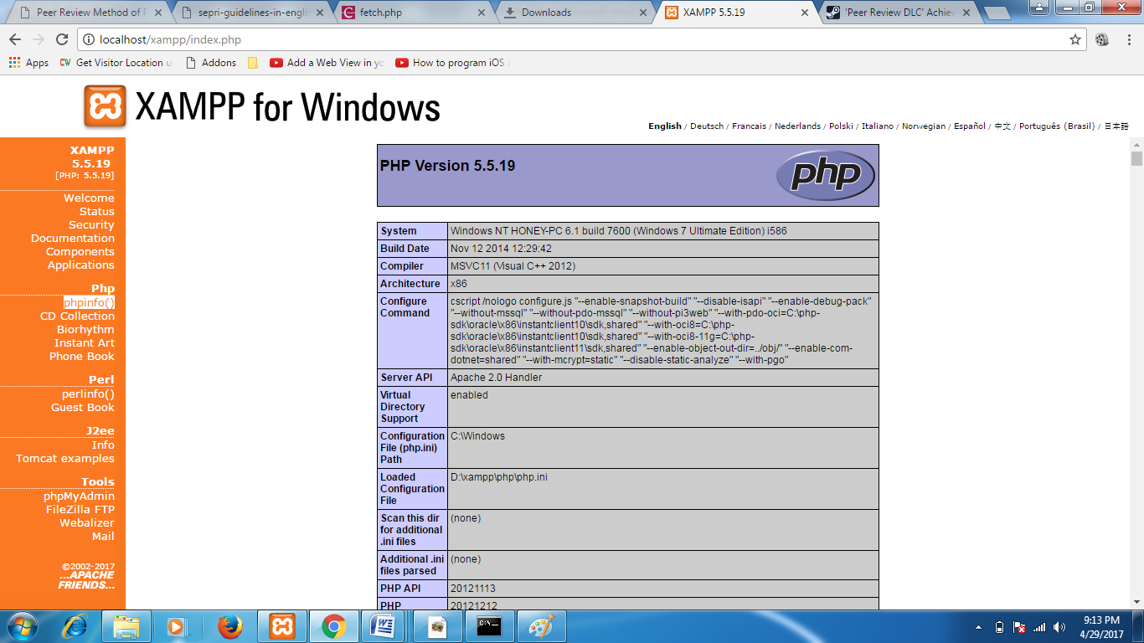
Figure: PHP(XAMPP)

6. CODING
<?php
include('includes/dbconnection.php');
session_start();
error_reporting(0);

?>
<!doctype html>
<htmllang="en">
<head>

<title>College Admission Management System||Home Page</title>
<!-- web fonts -->
<linkhref="//fonts.googleapis.com/css?family=Work+Sans:100,200,300,400,500,600,700,800,900&display=swap"rel="stylesheet">
<!-- //web fonts -->
<!-- Template CSS -->
<linkrel="stylesheet"href="assets/css/style-starter.css">
</head>
<body>

<?phpinclude('includes/header.php');?>
<sectionclass="w3l-main-slider"id="home">
<!-- main-slider -->
<divclass="companies20-content">

<divclass="owl-one owl-carousel owl-theme">
<divclass="item">
<li>
<divclass="slider-info banner-view bg bg2"data-selector=".bg.bg2">
<divclass="banner-info">
<divclass="container">
<divclass="banner-info-bg mx-auto text-center">
<h5>Better Education For A Better World</h5>
<aclass="btnbtn-secondary btn-theme2 mt-md-5 mt-4"href="contact.php">Contact Now</a>
</div>

</div>
</div>
</div>
</li>
</div>
<divclass="item">
<li>
<divclass="slider-info banner-view banner-top1 bg bg2"data-selector=".bg.bg2">
<divclass="banner-info">
<divclass="container">
<divclass="banner-info-bg mx-auto text-center">
<h5>Explore The World Of Our Graduates</h5>
<aclass="btnbtn-secondary btn-theme2 mt-md-5 mt-4"href="contact.php">Contact Now</a>
</div>
</div>
</div>
</div>
</li>
</div>
<divclass="item">
<li>
<divclass="slider-info banner-view banner-top2 bg bg2"data-selector=".bg.bg2">
<divclass="banner-info">
<divclass="container">
<divclass="banner-info-bg mx-auto text-center">
<h5>Exceptional People, Exceptional Care</h5>
<aclass="btnbtn-secondary btn-theme2 mt-md-5 mt-4"href="contact.php">Contact Now</a>
</div>
</div>
</div>
</div>
</li>
</div>
<divclass="item">
<li>
<divclass="slider-info banner-view banner-top3 bg bg2"data-selector=".bg.bg2">
<divclass="banner-info">
<divclass="container">
<divclass="banner-info-bg mx-auto text-center">
<h5>Explore The World Of Our Graduates</h5>
<aclass="btnbtn-secondary btn-theme2 mt-md-5 mt-4"href="services.html">Read More</a>
</div>
</div>
</div>
</div>
</li>
</div>
</div>
</div>

</div>

<scriptsrc="assets/js/owl.carousel.js"></script>
<!-- script for -->
<script>
$(document).ready(function(){
$('.owl-one').owlCarousel({
loop:true,
margin:0,
nav:false,
responsiveClass:true,
autoplay:false,
autoplayTimeout:5000,
autoplaySpeed:1000,
autoplayHoverPause:false,
responsive:{
0:{
items:1,
nav:false
},
480:{
items:1,
nav:false
},
667:{
items:1,
nav:true
},
1000:{
items:1,
nav:true
}
}
})
})
</script>
<!-- //script -->
<!-- /main-slider -->
</section>

<!-- features-4 block -->
<sectionclass="w3l-index1"id="about">
<divclass="calltoaction-20 py-5 editContent">
<divclass="container py-md-3">

<divclass="calltoaction-20-content row">
<divclass="column center-align-self col-lg-6 pr-lg-5">
<h5class="editContent">Welcome To Our Campus</h5>
<?php

$ret=mysqli_query($con,"select * from tblpage where PageType='aboutus' ");
$cnt=1;
while($row=mysqli_fetch_array($ret)){

?>
<pclass="more-gap editContent"><?phpecho$row['PageDescription'];?></p>
<?php}?>
<aclass="btnbtn-secondary btn-theme2 mt-3"href="about.php"> Read More</a>
</div>
<divclass="column ccont-left col-lg-6">
<imgsrc="assets/images/g1.jpg"class="img-responsive"alt="">
</div>
</div>
</div>
</div>
</section>
<!-- features-4 block -->
<sectionclass="services-12"id="course">
<divclass="form-12-content">
<divclass="container">
<divclass="grid grid-column-2 ">

<divclass="column1">
<divclass="heading">
<h3class="head text-white">Apply for Addmission</h3>
<h4>Limited Seat Available</h4>
<pclass="my-3 text-white">Vestibulum ante ipsumprimis in faucibusorciluctusetultricesposuerecubiliaCurae;
Nullamollisdapibusnunc, utrhoncus
turpissodalesquis. Integer sit ametmattis quam.</p>
</div>
</div>
<divclass="column2">
<aclass="btnbtn-secondary btn-theme2 mt-3"href="user/login.php"> Apply Here</a>
</div>
</div>
</div>
</div>
</section>

<sectionclass="w3l-price-2"id="news">
<divclass="price-main py-5">
<divclass="container py-md-3">
<divclass="pricing-style-w3ls row py-md-5">
<divclass="pricing-chart col-lg-12">
<h3class="">Latest Notices</h3><?php$query=mysqli_query($con,"select * from tblnotice ORDER BY ID DESC LIMIT 1");
while($row=mysqli_fetch_array($query)){
?>
<divclass="tatest-top mt-md-5 mt-4">
<divclass="price-box btn-layout bt6">
<divclass="grid grid-column-2">
<divclass="column-6">
<imgsrc="assets/images/g9.jpg"alt=""class="img-fluid">
</div>
<divclass="column1">

<divclass="job-info">

<h6class="pricehead"><?phpecho$row['Title'];?></h6>
<h5><?phpecho$row['CreationDate'];?></h5>
<p><?phpecho$row['Decription'];?></p>

</div>
</div>

</div>
</div>

</div>
<?php}?>
</div>

</div>
</div>
</div>
</section>
<!-- grids block 5 -->
<?phpinclude('includes/footer.php');?>
<scriptsrc="assets/js/jquery-3.3.1.min.js"></script>
<!-- //footer-28 block -->
</section>
<script>
$(function(){
$('.navbar-toggler').click(function(){
$('body').toggleClass('noscroll');
})
});
</script>
<!--jQuery first, then Popper.js, then Bootstrap JS -->
<scriptsrc="https://code.jquery.com/jquery-3.4.1.slim.min.js"
integrity="sha384-J6qa4849blE2+poT4WnyKhv5vZF5SrPo0iEjwBvKU7imGFAV0wwj1yYfoRSJoZ+n"crossorigin="anonymous">
</script>
<scriptsrc="https://cdn.jsdelivr.net/npm/popper.js@1.16.0/dist/umd/popper.min.js"
integrity="sha384-Q6E9RHvbIyZFJoft+2mJbHaEWldlvI9IOYy5n3zV9zzTtmI3UksdQRVvoxMfooAo"crossorigin="anonymous">
</script>
<scriptsrc="https://stackpath.bootstrapcdn.com/bootstrap/4.4.1/js/bootstrap.min.js"
integrity="sha384-wfSDF2E50Y2D1uUdj0O3uMBJnjuUD4Ih7YwaYd1iqfktj0Uod8GCExl3Og8ifwB6"crossorigin="anonymous">
</script>

<!-- Template JavaScript -->
<scriptsrc="assets/js/all.js"></script>
<!-- Smooth scrolling -->
<!--<script src="assets/js/smoothscroll.js"></script> -->
<scriptsrc="assets/js/owl.carousel.js"></script>

<!-- script for -->
<script>
$(document).ready(function(){
$('.owl-one').owlCarousel({
loop:true,
margin:0,
nav:true,
responsiveClass:true,
autoplay:false,
autoplayTimeout:5000,
autoplaySpeed:1000,
autoplayHoverPause:false,
responsive:{
0:{
items:1,
nav:false
},
480:{
items:1,
nav:false
},
667:{
items:1,
nav:true
},
1000:{
items:1,
nav:true
}
}
})
})
</script>
<?php
include('includes/dbconnection.php');
session_start();
error_reporting(0);
?>
<!doctype html>
<htmllang="en">
<head>

<title>College Adnission Management System||About Us</title>
<!-- web fonts -->
<linkhref="//fonts.googleapis.com/css?family=Work+Sans:100,200,300,400,500,600,700,800,900&display=swap"rel="stylesheet">
<!-- //web fonts -->
<!-- Template CSS -->
<linkrel="stylesheet"href="assets/css/style-starter.css">
</head>
<body>
<?phpinclude_once("includes/header.php");?>
<sectionclass="w3l-about-breadcrum">
<divclass="breadcrum-bg py-sm-5 py-4">
<divclass="container py-lg-3">
<h2>About Us</h2>
<p><ahref="index.php">Home</a>&nbsp; / &nbsp;About</p>
</div>
</div>
</section>
<!-- content-with-photo4 block -->
<sectionclass="w3l-content-with-photo-4">
<divid="content-with-photo4-block"class="pt-5">
<divclass="container py-md-5">
<divclass="cwp4-two row">
<?php

$ret=mysqli_query($con,"select * from tblpage where PageType='aboutus' ");
$cnt=1;
while($row=mysqli_fetch_array($ret)){

?>
<divclass="cwp4-text col-lg-6">
<h3><?phpecho$row['PageTitle'];?></h3>
<p><?phpecho$row['PageDescription'];?>
</p>

<?php}?>
</div>
<divclass="cwp4-image col-lg-6 pl-lg-5 mt-lg-0 mt-5">
<imgsrc="assets/images/g4.jpg"class="img-fluid"alt=""/>
</div>
</div>
</div>
</div>
</section>
<!-- content-with-photo4 block -->

<?phpinclude_once("includes/footer.php");?>
<scriptsrc="assets/js/jquery-3.3.1.min.js"></script>
<!-- //footer-28 block -->
</section>
<script>
$(function(){
$('.navbar-toggler').click(function(){
$('body').toggleClass('noscroll');
})
});
</script>
<!--jQuery first, then Popper.js, then Bootstrap JS -->
<scriptsrc="https://code.jquery.com/jquery-3.4.1.slim.min.js"
integrity="sha384-J6qa4849blE2+poT4WnyKhv5vZF5SrPo0iEjwBvKU7imGFAV0wwj1yYfoRSJoZ+n"crossorigin="anonymous">
</script>
<scriptsrc="https://cdn.jsdelivr.net/npm/popper.js@1.16.0/dist/umd/popper.min.js"
integrity="sha384-Q6E9RHvbIyZFJoft+2mJbHaEWldlvI9IOYy5n3zV9zzTtmI3UksdQRVvoxMfooAo"crossorigin="anonymous">
</script>
<scriptsrc="https://stackpath.bootstrapcdn.com/bootstrap/4.4.1/js/bootstrap.min.js"
integrity="sha384-wfSDF2E50Y2D1uUdj0O3uMBJnjuUD4Ih7YwaYd1iqfktj0Uod8GCExl3Og8ifwB6"crossorigin="anonymous">
</script>

<!-- Template JavaScript -->
<scriptsrc="assets/js/all.js"></script>
<!-- Smooth scrolling -->
<!--<script src="assets/js/smoothscroll.js"></script> -->
<scriptsrc="assets/js/owl.carousel.js"></script>

<!-- script for -->
<script>
$(document).ready(function(){
$('.owl-one').owlCarousel({
loop:true,
margin:0,
nav:true,
responsiveClass:true,
autoplay:false,
autoplayTimeout:5000,
autoplaySpeed:1000,
autoplayHoverPause:false,
responsive:{
0:{
items:1,
nav:false
},
480:{
items:1,
nav:false
},
667:{
items:1,
nav:true
},
1000:{
items:1,
nav:true
}
}
})
})
</script>
<!-- //script -->

7. TESTING
Software Testing is the process used to help identify the correctness, completeness, security, and quality of developed computer software. Testing is a process of technical investigation, performed on behalf of stakeholders, that is intended to reveal quality-related information about the product with respect to the context in which it is intended to operate. This includes, but is not limited to, the process of executing a program or application with the intent of finding errors. Quality is not an absolute; it is value to some person. With that in mind, testing can never completely establish the correctness of arbitrary computer software; testing furnishes a criticism or comparison that compares the state and behavior of the product against a specification. An important point is that software testing should be distinguished from the separate discipline of Software Quality Assurance (SQA), which encompasses all business process areas, not just testing.
There are many approaches to software testing, but effective testing of complex products is essentially a process of investigation, not merely a matter of creating and following routine procedure. One definition of testing is "the process of questioning a product in order to evaluate it", where the "questions" are operations the tester attempts to execute with the product, and the product answers with its behavior in reaction to the probing of the tester[citation needed]. Although most of the intellectual processes of testing are nearly identical to that of review or inspection, the word testing is connoted to mean the dynamic analysis of the product—putting the product through its paces. Some of the common quality attributes include capability, reliability, efficiency, portability, maintainability, compatibility and usability. A good test is sometimes described as one which reveals an error; however, more recent thinking suggests that a good test is one which reveals information of interest to someone who matters within the project community.

Testing Concepts

Testing Methodologies
- Black box Testing:
- White box Testing.
- Gray Box Testing.

Levels of Testing
  - Unit Testing.
  - Module Testing.
  - Integration Testing.
  - System Testing.
  - User Acceptance Testing.

Types of Testing
  - Smoke Testing.
  - Sanitary Testing.
  - Regression Testing.
  - Re-Testing.
  - Static Testing.
  - Dynamic Testing.
  - Alpha-Testing.
  - Beta-Testing.
  - Monkey Testing.
  - Compatibility Testing.
  - Installation Testing.
  - Adhoc Testing.
  - Ext….

TCD (Test Case Documentation)
STLC
  - Test Planning.
  - Test Development.
  - Test Execution.
  - Result Analysis.
  - Bug-Tracing.
  - Reporting.
Microsoft Windows – Standards
Manual Testing
Automation Testing (Tools)
  - Win Runner.
  - Test Director.
Testing:
The process of executing a system with the intent of finding an error. Testing is defined as the process in which defects are identified, isolated, subjected for rectification and ensured that product is defect free in order to produce the quality product and hence customer satisfaction.
Quality is defined as justification of the requirements
Defect is nothing but deviation from the requirements
Defect is nothing but bug.
Testing --- The presence of bugs
Testing can demonstrate the presence of bugs, but not their absence
Debugging and Testing are not the same thing!
Testing is a systematic attempt to break a program or the AUT
Debugging is the art or method of uncovering why the script /program did not execute properly.
Testing Methodologies:
Black box Testing: is the testing process in which tester can perform testing on an application without having any internal structural knowledge of application.
Usually Test Engineers are involved in the black box testing.
White box Testing: is the testing process in which tester can perform testing on an application with having internal structural knowledge.
Usually The Developers are involved in white box testing.
Gray Box Testing: is the process in which the combination of black box and white box tonics’ are used.
Test Planning:
1. Test Plan is defined as a strategic document which describes the procedure how to perform various testing on the total application in the most efficient way.
2. This document involves the scope of testing,
3. Objective of testing,
4. Areas that need to be tested,
5. Areas that should not be tested,
6. Scheduling Resource Planning,
7. Areas to be automated, various testing tools Used.

Test Development:
Test case Development (check list)
Test Procedure preparation. (Description of the Test cases).
Implementation of test cases.Observing the result.
Result Analysis:
Expected value: is nothing but expected behavior Of application.
Actual value: is nothing but actual behavior of application
Bug Tracing: Collect all the failed cases, prepare documents.
Reporting: Prepare document (status of the application)
Types Of Testing:
Smoke Testing: is the process of initial testing in which tester looks for the availability of all the functionality of the application in order to perform detailed testing on them. (Main check is for available forms)
Sanity Testing: is a type of testing that is conducted on an application initially to check for the proper behavior of an application that is to check all the functionality are available before the detailed testing is conducted by on them.
Regression Testing: is one of the best and important testing. Regression testing is the process in which the functionality, which is already tested before, is once again tested whenever some new change is added in order to check whether the existing functionality remains same.
Re-Testing: is the process in which testing is performed on some functionality which is already tested before to make sure that the defects are reproducible and to rule out the environments issues if at all any defects are there.
Static Testing: is the testing, which is performed on an application when it is not been executed.ex: GUI, Document Testing
Dynamic Testing: is the testing which is performed on an application when it is being executed.ex: Functional testing.
Alpha Testing: it is a type of user acceptance testing, which is conducted on an application when it is just before released to the customer.
Beta-Testing: it is a type of UAT that is conducted on an application when it is released to the customer, when deployed in to the real time environment and being accessed by the real time users.
Monkey Testing: is the process in which abnormal operations, beyond capacity operations are done on the application to check the stability of it in spite of the users abnormal behavior.
Compatibility testing: it is the testing process in which usually the products are tested on the environments with different combinations of databases (application servers, browsers…etc) In order to check how far the product is compatible with all these environments platform combination.
Installation Testing: it is the process of testing in which the tester try to install or try to deploy the module into the corresponding environment by following the guidelines produced in the deployment document and check whether the installation is successful or not.
AdhocTesting:Adhoc Testing is the process of testing in which unlike the formal testing where in test case document is used, without that test case document testing can be done of an application, to cover that testing of the future which are not covered in that test case document. Also it is intended to perform GUI testing which may involve the cosmotic issues.

8. OUTPUT SCREENS
Home Page

About Us

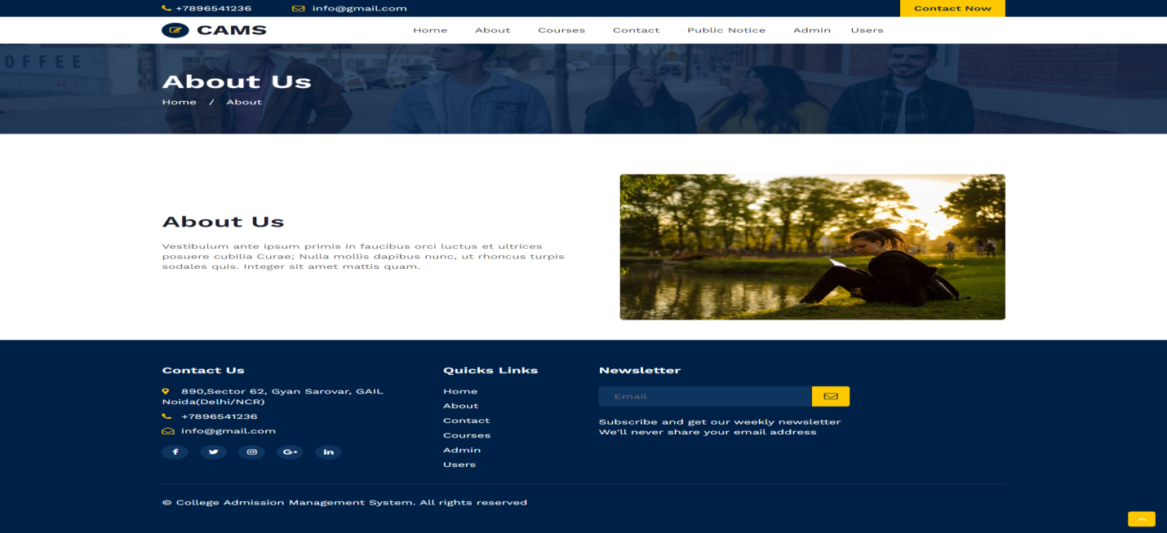
Contact Us

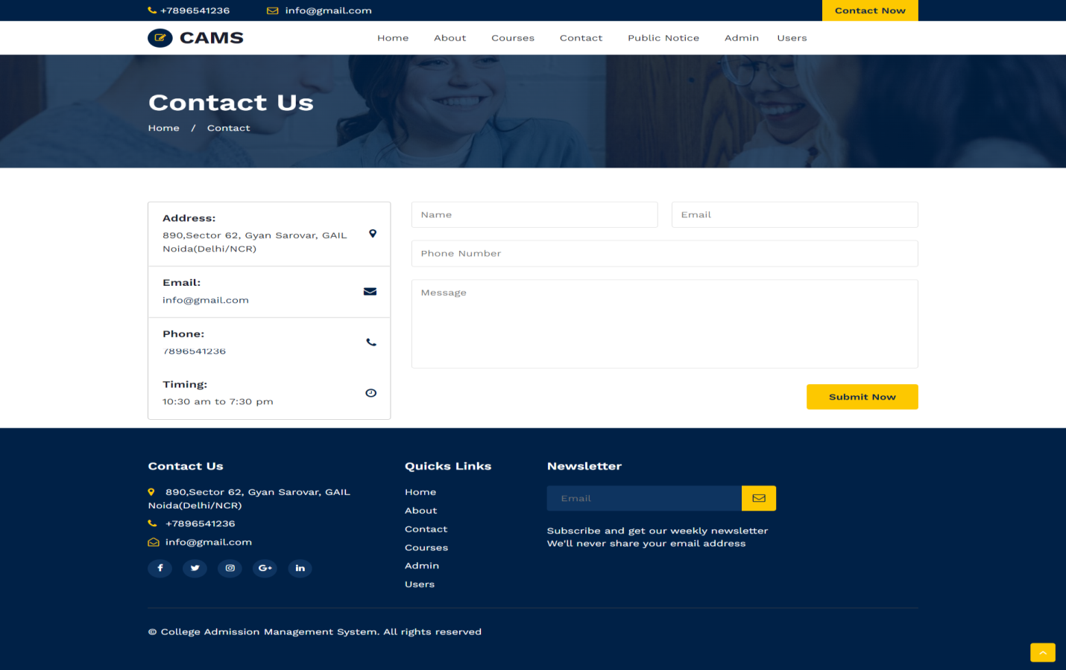

Courses

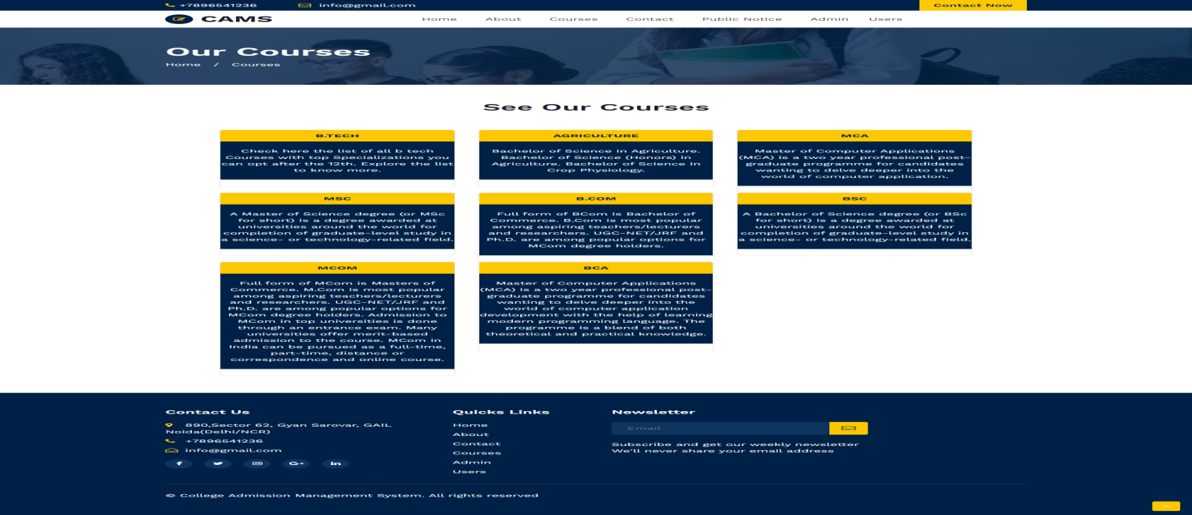
Notice

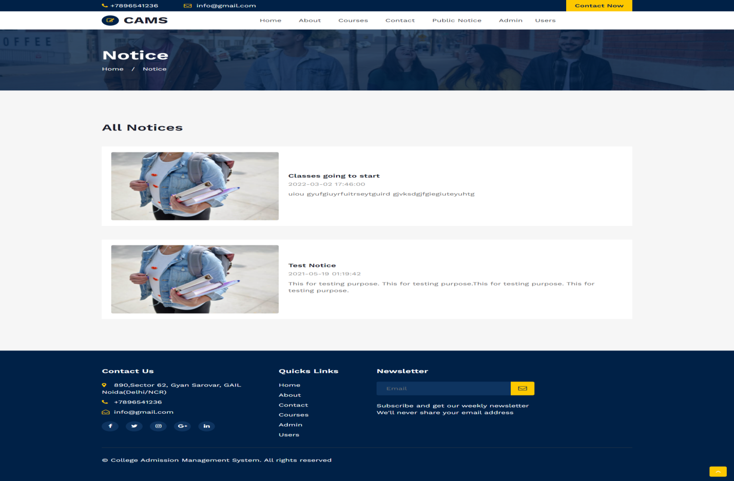

Students Panel
Signup
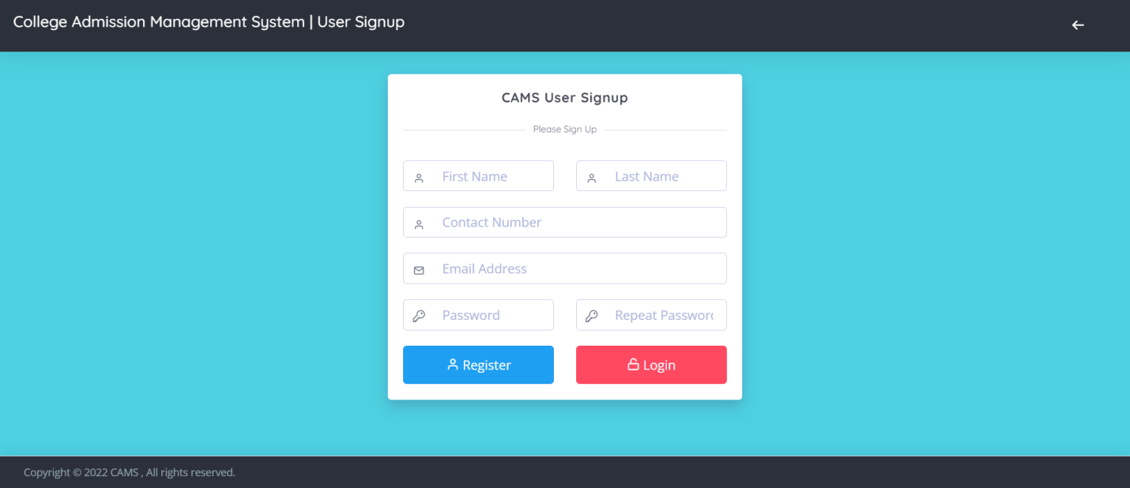

Login Page

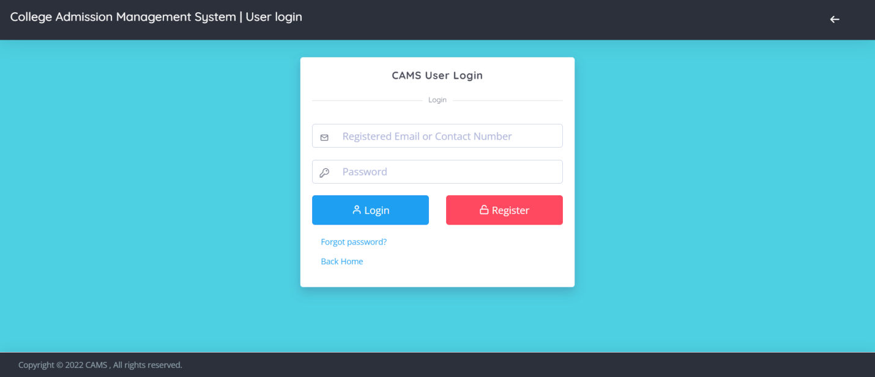

Dashboard
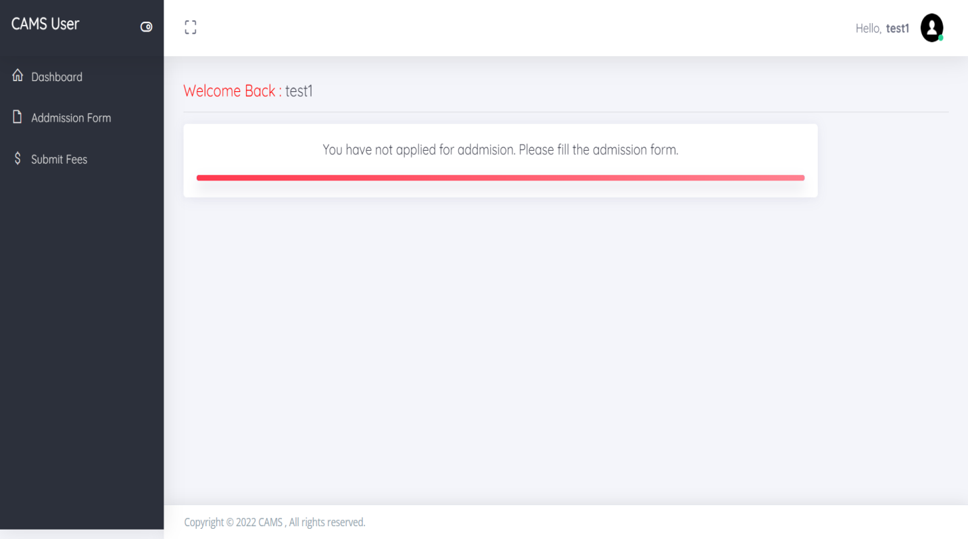

Profile
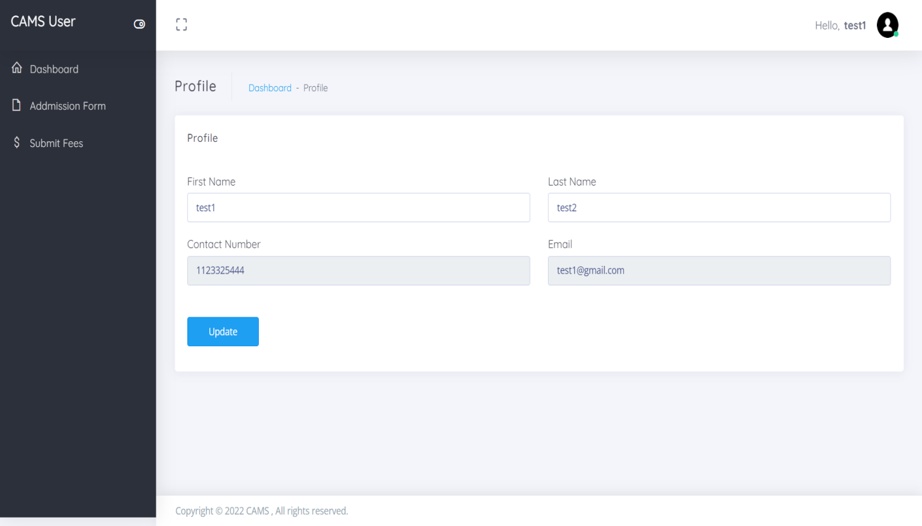

Change Password

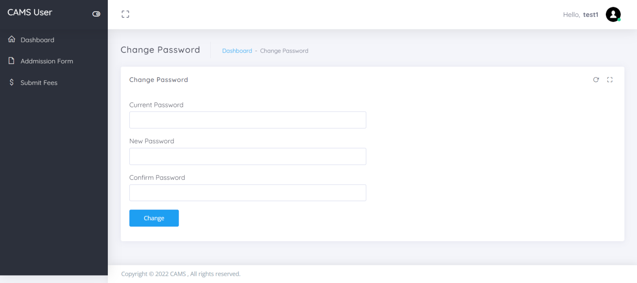
Admission Form
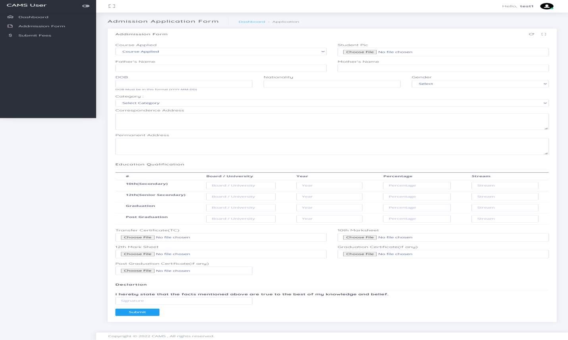

Add Course
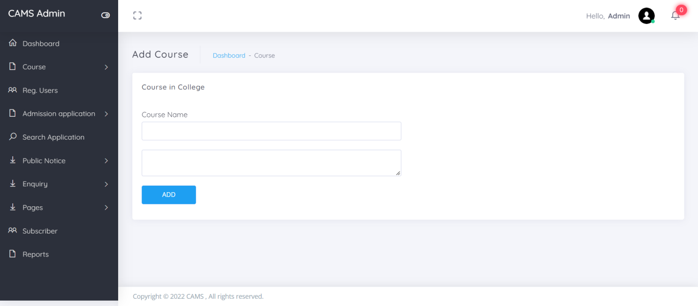
View Application Form

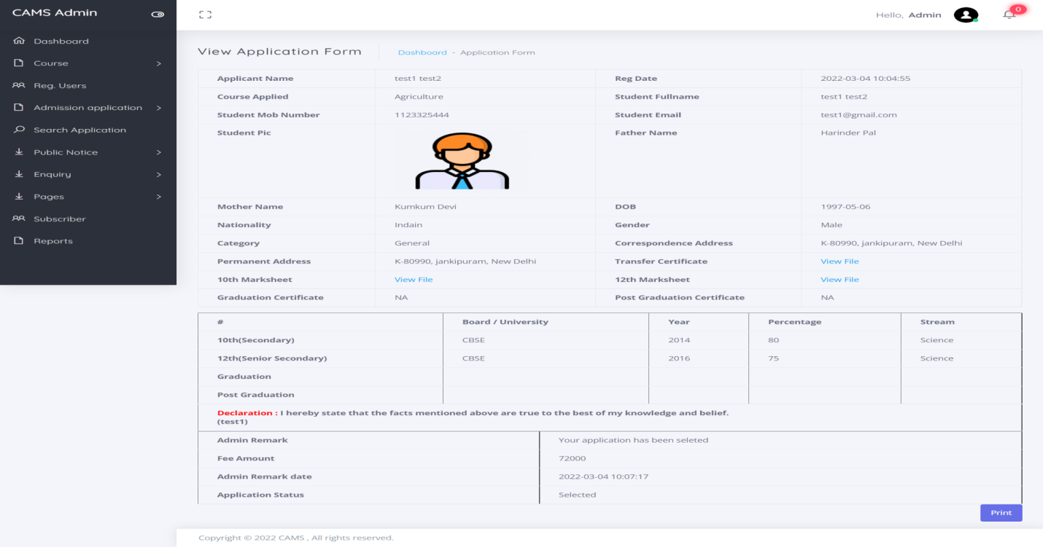

9. CONCLUSION
In this way we are going to develop college admission system, which is helpful for Reduction in manual work so less manpower required. Students’ records can be accessed within few seconds, Clarity in account section. Our system primarily focuses on building an efficient and user friendly communication system for the educational institutions.

10. BIBLIOGRAPHY
Reference text books
- https://www.tutorialspoint.com/php/php_introduction.htm
- http://php.net/manual/en/intro-whatis.php
- Algorithm and applications in java 3rd edition by SatrajSahni (Tata McGraw Hill).
- Classical Data Structures by Samantha (Pearson education).
- Software Engineering practice and principles 6th edition by Roger Pressmen (Tata McGraw Hill).
- Internet & World Wide Web How to program 3rd edition by Deitel&Deitel and Goldberg (Pearson education).
- Web enabled commercial application development using Java 2.0 by Ivan Bayross (Prentice Hall of India).
- Data base System Concepts 4th edition by Silbershatz, Korth, and Sudharshan(Tata McGraw Hill).
- Fundamentals of Data base systems 4th edition by RamezElmasri and ShamkantB.Navathe(Pearson education).
For PHP
- https://www.w3schools.com/php/default.asp
- https://www.sitepoint.com/php/
- https://www.php.net/

For MySQL
- https://www.mysql.com/
- http://www.mysqltutorial.org

For XAMPP
- https://www.apachefriends.org/download.html

